**Kafka monitoring with Graphite**

<https://github.com/damienclaveau/kafka-graphite>

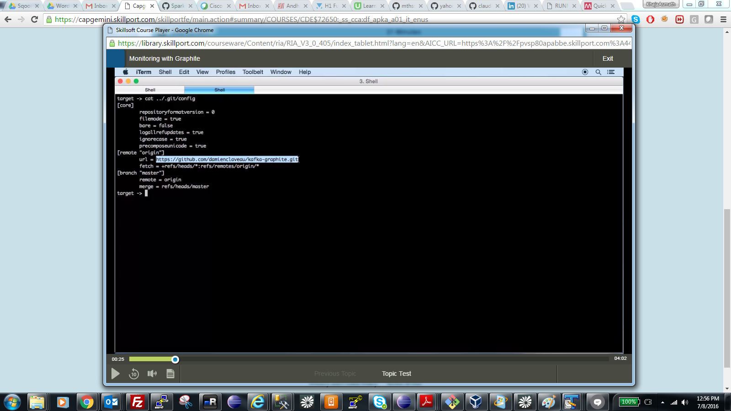

**Build with maven and see if it has uber jar like below.**

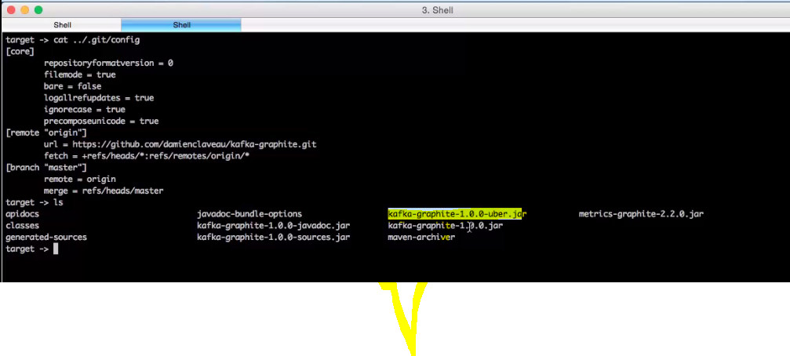

**VVV. IMP 🡪 copy jars in lib folder of kafka as shown below.**

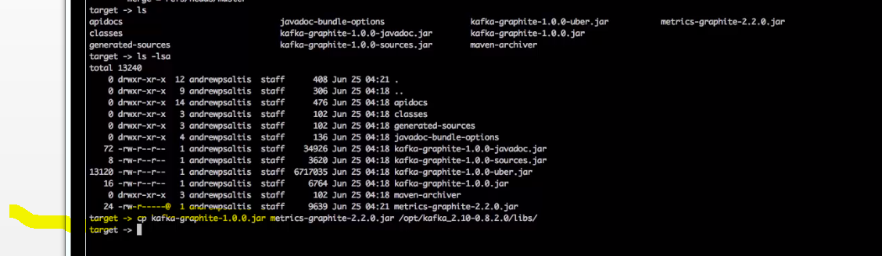

**Add some properties inside conf/server.properties file**

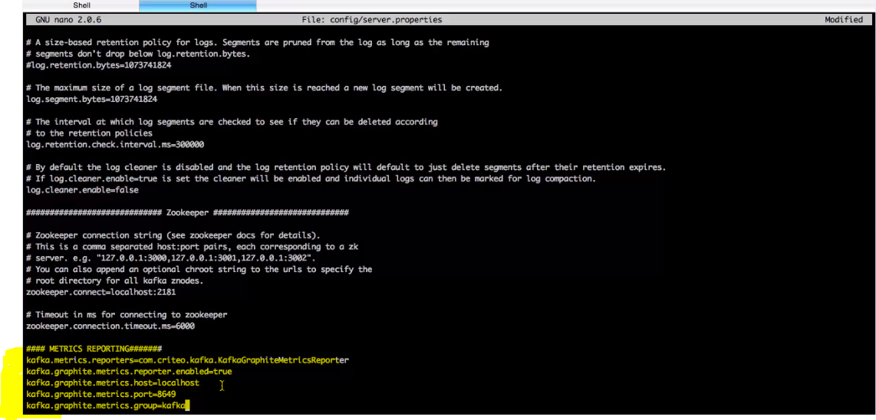

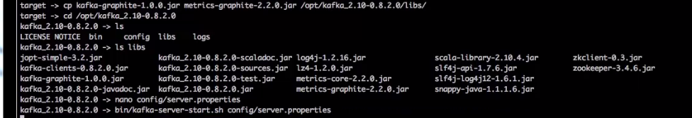

**After that simply start the broker**